A Risk-based Approach

The level of scrutiny necessary for an organization to reach reasonable confidence that it is engaged in a normal, legitimate business transaction varies with corruption risk. The level of corruption risk determines how much scrutiny is required to be able to defend before a judge or a prosecutor that the organization is con dent it is dealing with a *bona de* third party. The higher the risk, the broader and deeper the third-party due diligence should be.

Risk-based Due Diligence Process Map

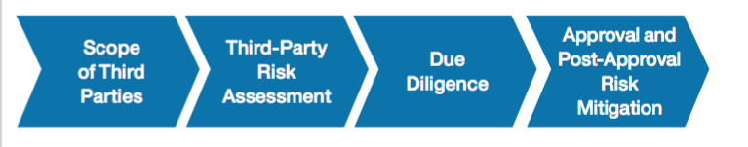

Effective Implementation of Due Diligence Process

**Scope of Third Parties**

*Understanding the universe of third parties and which ones should be subject to due diligence*

**Third-Party Risk Assessment**

*Assessing the level of corruption risk associated with individual third parties*

**Due Diligence**

*Conducting risk-based anti-corruption due diligence*

**Approval Process and Post-Approval Risk Mitigation**

*Managing the approval process and mitigating identified risks*

Defining Third Parties

It is important that third-party due diligence encompass third parties contracted in both sales and supply channels. While experience shows that sales intermediaries (such as agents or distributors) may be more frequently abused than suppliers in order to relay corrupt payments, suppliers can likewise be used corruptly.

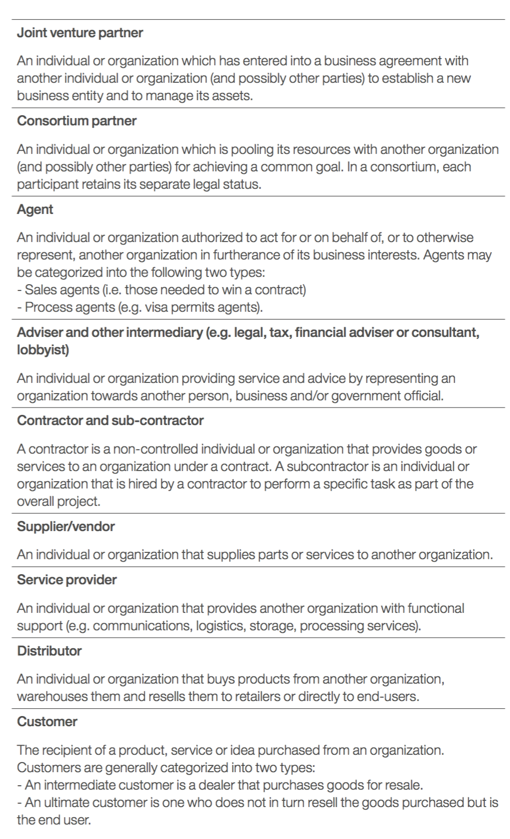

The list of definitions above may be useful to help organizations clearly understand and categorize their universe of third parties. This list is not exhaustive; some of the definitions may be overlapping and thus covering the same type of business relationships. Each organization should therefore develop its own list to draw a full inventory of third parties with whom it is engaged.

Initial Screening of Third Parties / Vendors

To perform an initial screening to determine “in scope” third parties, organizations may start by asking themselves the following questions:

* Is the third party in an industry or geographic location perceived to have higher corruption risks?
* Will the third party perform services on behalf of the organization, or be authorized to represent the organization vis-à-vis other third parties?
* Is it reasonable to expect that the third party will come into contact with government officials when representing the organization?
* Will the third party be in a position to influence decisions or the conduct of other third parties for the benefit of the organization?

A positive answer to any of these questions may lead organizations to consider the third party under review as an “in scope” third party. In practice, agents, advisers and other intermediaries, as well as joint-venture and consortium partners, will likely be considered “in scope” third parties. Contractors, suppliers and a range of other business partners may also fall in this category if they are to perform services on behalf of the organization.

Assessing the level of corruption risk associated with   
individual third parties

Once an organization has identified which of its third parties are “in scope” for risk-based due diligence, the next step is to define the risk and find the appropriate level of due diligence for each entity. The appropriate amount of due diligence should be guided by the results of a risk assessment process. The idea is to assess third parties as high-, medium- or low-risk third parties. Such risk assessment can be made for each individual third party or for groups of third parties. The level of risk will ultimately determine the amount of due diligence that needs to be performed, with high-risk third parties subject to a more detailed due diligence process.

*Key Risk Indicators*

**Geographic location**

*High-risk factors*: The geographic location where the third party resides and/or operates (as per the contract) is:

* A country perceived to be a high-risk country for corruption (see for example Transparency International’s Corruption Perceptions Index)
* A jurisdiction known to have high levels of bank secrecy and presenting a high risk for facilitating illicit financial flows (see for example the Tax Justice Network’s Financial Secrecy Index)
* A jurisdiction that encourages or requires organizations to hire local agents to transact business for the government

**Industry**

*High-risk factors*:

* The industry with which the third party conducts business transactions is perceived to present a high risk for corruption (see for example Transparency International’s Bribe Payers Index)
* The third party belongs to an industry with a history of anti-corruption enforcement scrutiny

**Background and identity of the third party**

*High-risk factors:*

* Initial Internet searches and use of news services have revealed glaring problems related to the third party’s reputation for integrity.
* The third party, or any of its senior officials, has previously been subject to regulatory action or legal proceedings as a result of alleged breaches of anti-corruption laws.
* The third party, or any of its senior officials, appears on a denied parties/persons list in consequence of national or international sanctions or as a result of past misconduct.
* The third party has little or no experience in the relevant industry sector and/or is unknown to the organization.

**Connection with government officials or entities**

*High-risk factors:*

* The third party, in the course of doing work for your organization, will have frequent interaction with government officials (including customs officials), governmental agencies or government-controlled entities4.
* The third party is wholly or partly (directly or indirectly) owned by a government official/entity or has direct or indirect links with government officials/entities.
* The third party has previously worked for government, or is closely connected with the political elite.

**Compensation structure of the proposed arrangement**

*High-risk factors:*

* The third party’s compensation is to be based on performance (i.e. success fees, bonus fees and other contingency fees).
* The third party requires payment by unusual means (e.g. deviating from standard practice, to multiple accounts, with upfront payments, split into small amounts, in cash or similar, in a country or currency that is different from that of the third party’s domicile or the country where the work will be performed).
* The third party’s compensation is to take the form of a political or charitable contribution.

**Additional factors related to the scope of the services to be rendered**

*High-risk factors:*

- The third party’s role is to enhance the organization’s chances of winning commercial and/or government contracts.

- The third party requests discretionary authority to handle local matters alone.

**Selection of the third party**

*High-risk factors:*

- The third party was recommended by a customer.

- The retention of this specific third party was encouraged or required by a government official.

Risk Assessment Process

For each of the risk indicators detailed above, an organization should evaluate whether the third party and the business relationship under review present a high, medium, or low corruption risk. These indicators should then be reviewed together so that judgement can be applied on the basis of an overall risk evaluation (high, medium or low), which will trigger the level of due diligence to be applied.

Management and employee interviews are a valuable tool to help assess and substantiate risk evaluations when conducting third- party risk assessment. These conversations can provide an in-depth view of the business and help the organization benchmark what is normal in terms of scope, quantity and usual terms of third-party business relationships. The interviews can also help provide an overview of corruption risks which have either manifested historically or could materialize at present.

*Key questions to consider when interviewing business managers and employers include:*

* What are third-party contractors used for?
* When are they needed, and when can the company do without?
* What is a relevant third party’s normal expertise?
* Where and how do these third parties normally operate, and what are their normal deliverables?
* What is their normal compensation scheme?
* What documentation is normally kept within the company on third-party transactions?
* What part of the relevant business division’s revenue depends on sales intermediaries?
* How often are third parties usually changed?
* What is the usual selection process for third parties?
* Which third parties are involved in governmental contracts and for what purpose?

Management and employee interviews can also help get to the details of specific corruption risks or control weaknesses in a business unit by asking questions such as:

* Do you use non-standard third-party agreements?
* Do you pay rates exceeding the normal fee level?
* Have you used third parties with only post-office boxes in offshore jurisdictions and no physical offices?
* Have you used third parties where nobody ever saw their representative in person?
* Is it possible for anyone to tweak matters in the course of third-party transactions (e.g. by inflating invoices, fabricating agreements, manipulating the selection process etc.) in order to abuse third parties to covertly siphon off money from the company which subsequently may be used to corrupt others?
* What are some of the suboptimal or missing controls which could facilitate such tweaks?

In many organizations, the responsibility for conducting the risk assessment lies with the individuals responsible for the third-party relationship. Because the risk assessment of a third party is subject to good faith judgement, it is important that the risk assessment and evaluation also include consultation with and inputs from independent subject-matter experts (e.g. legal, compliance, internal audit, security and local experts). This will help ensure objectivity in the process by allowing a second set of independent eyes to weigh in on the assessment.

At the end of the risk assessment process, the evaluator should justify and document their decision to categorize an entity or individual as a high-, medium- or low-risk third party.

*Good practice tips*

Conduct Spot Checks to Deter Abuse in the Process

Use your compliance team to conduct spot checks of the risk assessment process. This will help reduce abuse in the system and ensure that the risk assessment process is well understood and applied by business units of the organization.

Use Technology to Make the Process More Efficient

Technology can help make a traditionally paper-based process more efficient. Several compliance software programmes providing for direct data input, work-flow management and red-flag alerts are now available in the market.

Key Focus Areas for High-Risk Third Parties

1. ***Organization and Affiliations***

In normal, bona fide business transactions, a third party will not be owned by, or closely affiliated with, a decision-maker (e.g. a public official, or a manager or purchaser within a private entity) empowered to award business to the organization.

Therefore, focus areas for data collection related to the third party’s organization and its affiliations may include:

* Contact information
* Ownership structure
* Financial situation
* Whether the third party, or any key employee or senior management member, is related in any way to a public official
* Whether any shareholder or partner of the third party is owned in whole or in part by a public official or a person related in any way to a public official
* Whether public officials or a member of a public official’s family have any interest or stand to benefit in any way as a result of the proposed agreement

*Compliance Health Check*

A compliance health check is a plausibility test based on limited, reasonable documentary review that encompasses questions relating to the third party’s internal organization and its capacity to counter corruption.

The aim of conducting a compliance health check is to verify the existence, within the third party’s internal organization, of:

* A code of conduct
* Internal anti-corruption policies (for example, a whistleblower policy) - A compliance function
* Internal compliance trainings
* Internal audits in which compliance features as a topic

The compliance health check should be conducted to the extent reasonably appropriate in view of the geographic and industry risk, and the size and complexity of the third party’s organization.

1. ***Necessity and Proper Retention***

In normal, bona de business transactions, organizations engage with third parties only when they need them and they know what specific products or services they need them for. For example, your organization may need a distributor in a geographic area where its own sales force is not sufficiently staffed or sufficiently knowledgeable.

Key questions to ask related to the necessity for and selection of the third party may include:

* Why is the proposed relationship necessary?
* Why was this third party chosen?
* What other parties were considered as candidates?
* Does the third party plan to use any other entities or individuals, including subsidiaries, affiliates, partnerships or joint ventures, to perform services under the proposed agreement?
* Does the organization have previous or current relationships with the third party? Is it a known entity?

Also, in the course of normal, legitimate business transactions, an organization will ensure that it properly retains the third parties it needs. For example, it will not just choose any supplier for obtaining raw materials. Rather, it will ask various suppliers for competing offers and select the most suitable candidate in terms of quality, price and expertise.

Moreover, every organization meets natural fluctuation cycles. Some third parties will be replaced by others at certain intervals, be it because of changes in the needs of the business, or because the third parties are outrun by their competitors. Against this background, it may look suspicious if local management is reluctant to even look at the option of changing suppliers after a period exceeding normal fluctuation cycles, unless there is a convincing explanation.

Other questionable patterns to be explored are:

* + It remains unclear what services the third party is providing, or what these services are used for.
  + A sales consultant is retained in a geographic area or industry which is already sufficiently covered by existing (internal or external) sales forces.
  + Retention of the third party was required or “warmly recommended” by a public official or a decision-maker in the private sector with whom your company has business dealings.
  + Local management is reluctant to subject retention of the third party to a tender process (where such process has been benchmarked as normal).

1. ***Expertise***

In normal, bona de business transactions, organizations know what kind of expertise is required from the third party they are looking to retain.

A key question to ask relating to the expertise of the third party is:

* + Does the third party, or its key employees, possess the necessary professional degrees, experience, regulatory licenses and certificates to perform services under the proposed agreement?

1. ***Compensation, Fees and Method of Payment***

The fees paid to the third party should be reasonably commensurate with the services performed or goods delivered. This will be the case if the fee complies with normal market prices or other (e.g. internal) benchmarks. For example, an organization has to be able to explain why it pays a sales agent in Canada a commission of 2% of the sales volume, whereas in Equatorial Guinea it pays 10% for the same type of services.

* Does the compensation expected by the third party vary significantly from what is dictated by local market prices or internal benchmarks for similar services?
* Has the third party, or any key employee or senior management member of the third party, made comments to the effect that any particular payment, contribution or other activity is needed to “get the business” or “make necessary arrangements”?
* Has anyone, including the third party, requested that any payment be made out to “cash” or “bearer”, or that payments be made in some other similar form?

1. ***Integrity***

In normal, bona de business transactions, organizations abstain from contracting a third party whose integrity is questionable for the mere reason that behavioural anomalies and possible law enforcement activities may jeopardize the proper performance of this third party.

*Legal Proceedings*

* Has the third party, or any key employee or senior management member of the third party, ever been convicted of a felony, misdemeanour or any other crime? Has the third party made any settlements out of court for matters related to corruption, facilitation payments or fraud?
* Is there negative press coverage or findings in publicly accessible registers or lings indicating any regulatory or legal proceedings of this nature pending against the third-party organization or any of its key employees or senior management?
* Does the third party, or any of its key employees or senior management, appear on a denied-parties or -persons list?

*References*

* What is the general reputation of the third party according to its business/bank references and the opinion of other parties interviewed?

*Other questionable behaviour patterns*

* The third party is incorporated offshore with no evidently legitimate reason.
* The third party uses bank accounts in third countries (i.e. neither in the country of service nor in the country of the third party’s incorporation) and lacks any evidently legitimate reason to do so.
* The third party uses bank accounts in countries with a low rating on the Tax Justice Network’s Financial Secrecy Index5.
* The third party asks for cash payment, or advance payments (where advance payments are not customary), or for splitting of the payment in several small instalments (each of which seems to fall below usual de *minimis* thresholds for anti-money laundering checks conducted by banks).
* The third party is reluctant to answer due diligence questions, in particular questions on ownership or affiliations, or answers relevant questions evasively.
* The third party has a history of selling unusually large volumes to public buyers at high prices, or without tenders (where tenders are usual), or at otherwise preferred conditions.
* The third party uses sub-contractors where such use is not customary (e.g., an agent uses an agent).
* The third party suggests, in the course of negotiations, to suddenly contract not with itself but instead with another third party affiliated with it, or suggests the use of an unnecessarily complex transaction structure whose legitimate purpose is not spontaneously clear

For certain high-risk third parties, the assistance of an external due diligence service provider may be needed to undertake the following additional tasks:

* + Obtain information on previous company positions, interests of the owner and the operator’s key principals.
  + Conduct live, local language media research on the owner, the operator and its key principals.
  + Conduct independent bankruptcy and litigation checks.
  + Check the owner, operator and key principals against watch lists.
  + Obtain reputational intelligence through local investigators on the owner, operator and key principals.

Sample Red Flag Check List

